Creating a myApps Account
https://myapps.wvsao.gov/
Create Account -
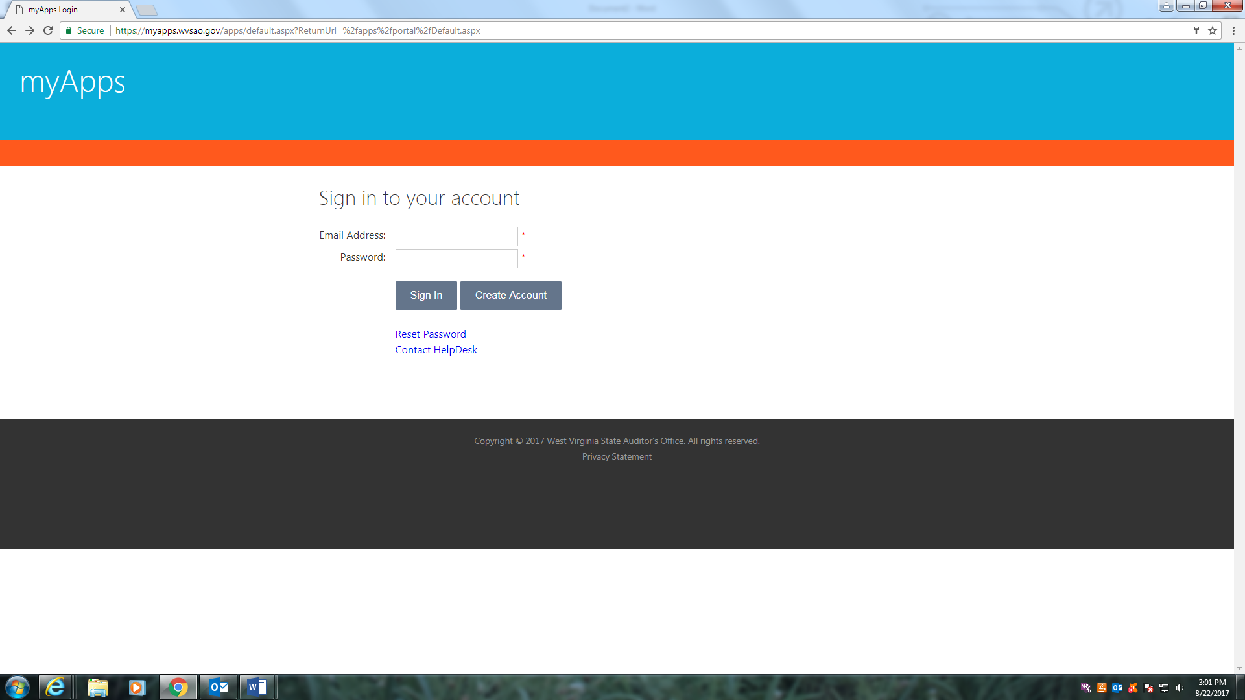
Click - I understand and agree to the terms of this contract as stated above.
Next button
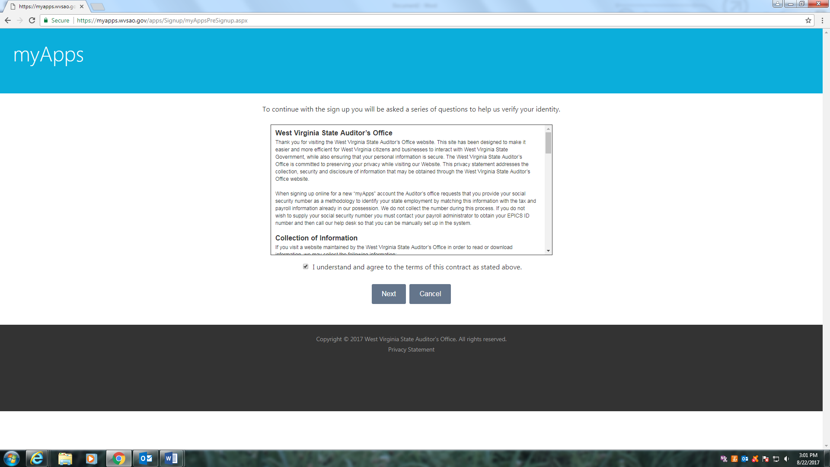

Fill out personal information –
Sign up button
