Blackboard Training

Glenville State College Office of Technology

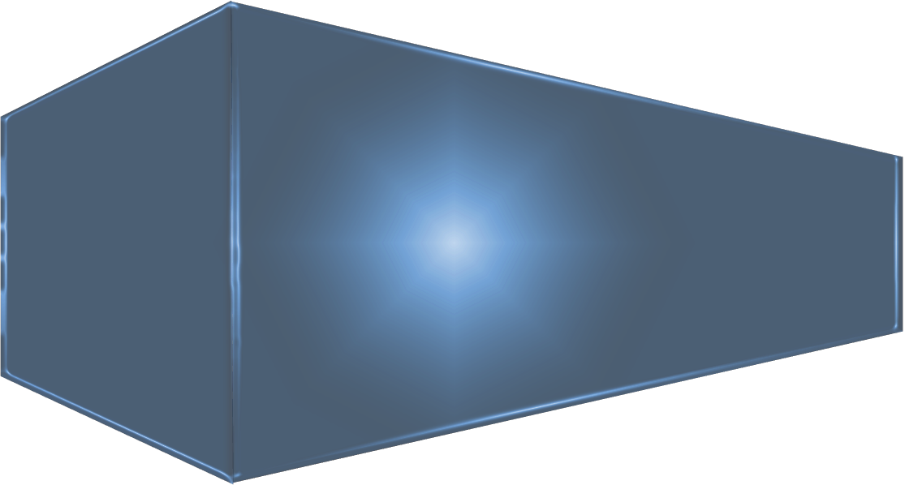
Fall 2019
Table of Contents

Logging into Blackboard Learn ...................................................................................................................... 3

Overview of the Learn Dashboard ................................................................................................................ 5

Standard Course Template............................................................................................................................7

Working in Your Course........................................................................................................................................9

Creating Announcements ............................................................................................................................ 12

Start Here Orientation..................................................................................................................................13

Course Content ............................................................................................................................................1 3

Adding Course Content................................................................................................................................1 4

Example of a Course Layout.........................................................................................................................1 6

Adding a File.................................................................................................................................................17

Adding an Image ..........................................................................................................................................18

Adding a URL (Web link) ..............................................................................................................................19

Creating a Test .............................................................................................................................................22

Edit the Test Options …………………………………………………………………………………………………………………….…….26

Setting Adaptive Release .............................................................................................................................28

Sending Email...............................................................................................................................................30

Bb Help.........................................................................................................................................................31

Student Lounge………....................................................................................................................................32

Syllabus........................................................................................................................................................32

Creating an Assignment...............................................................................................................................33

Creating a Discussion Board.........................................................................................................................35

Navigating the Grade Center .......................................................................................................................40

Full Grade Center.........................................................................................................................................41
Copying Course Content……………………………………………………………………………………………………………………......45

Questions ....................................................................................................................................................49

Logging into Blackboard Learn
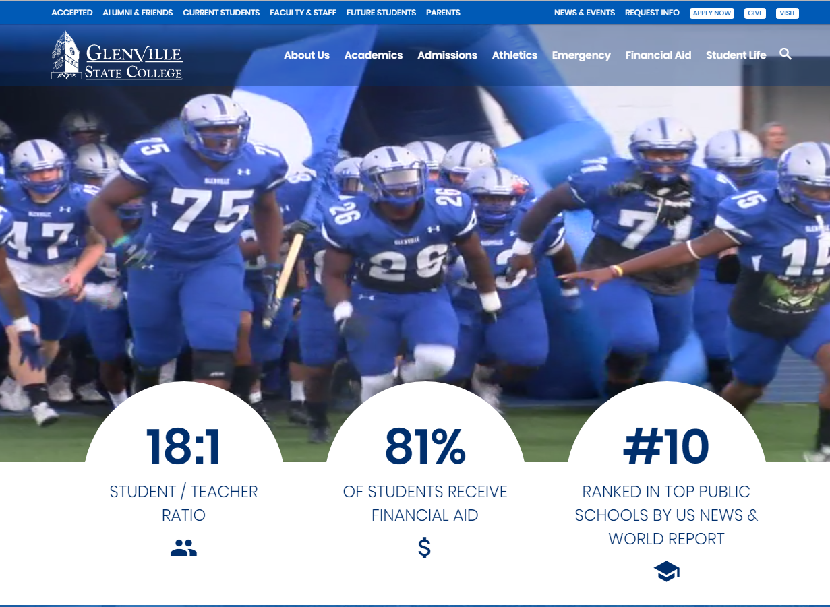
To login to Blackboard Learn, go to the Glenville State College website http://www.glenville.edu and click the Faculty & Staff link from the menu.
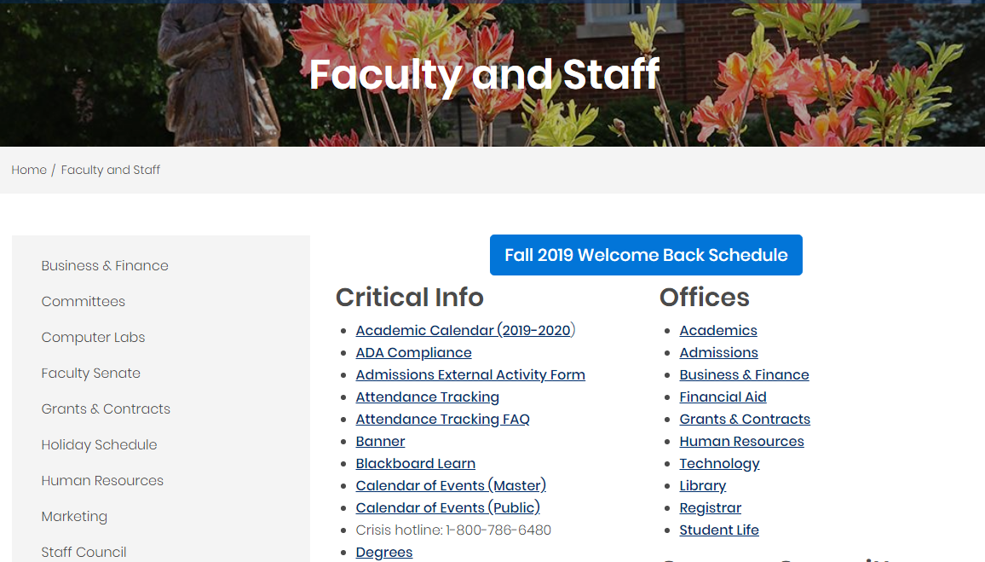
Select Blackboard Learn.
Logging into Blackboard Learn 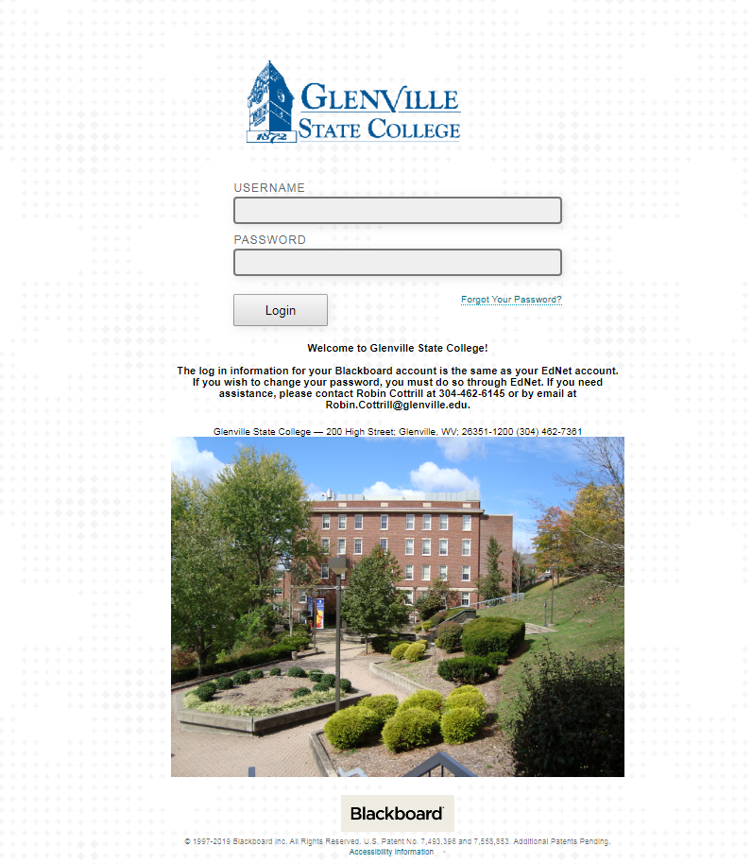
Username/Password
Your username and password are the same as your EdNet.
Your username is your ID number. Your password is more than likely your birthdate DDMMYY (make sure you have the correct format.) Students also log in with their EdNet credentials. If you want to change your password you must do so in Ednet.

Overview of the Learn Dashboard
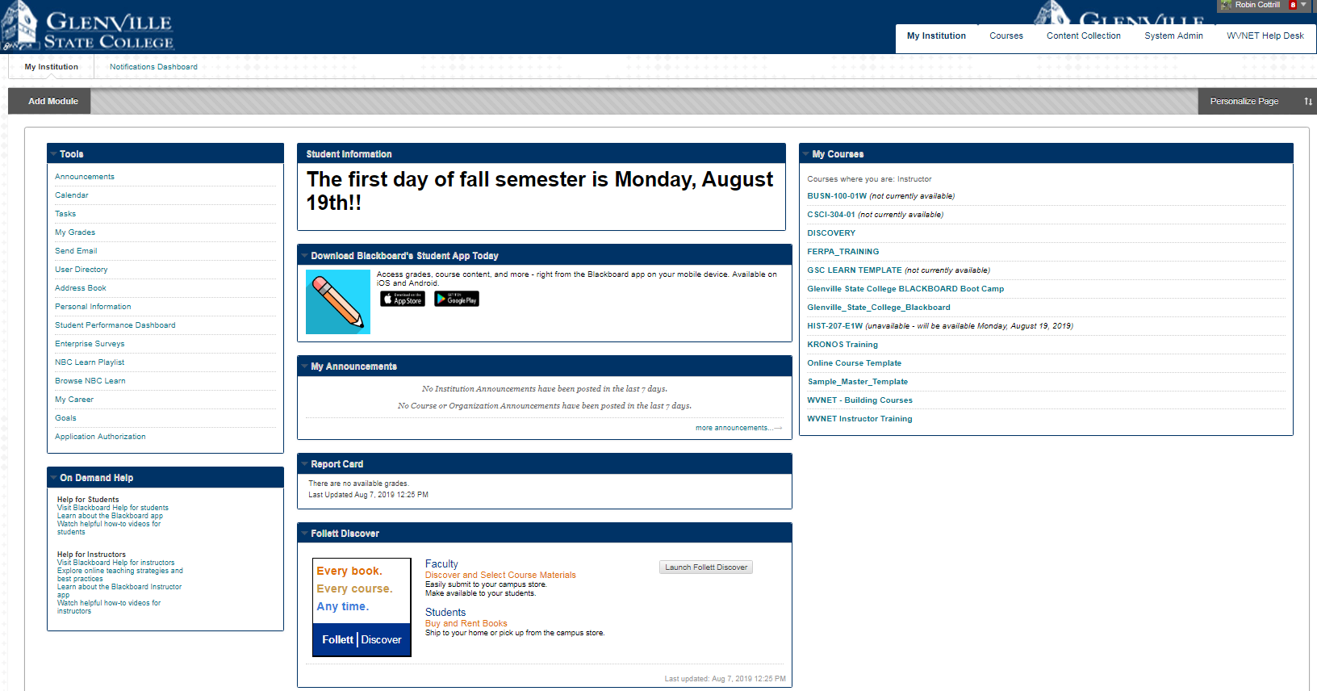
This is the main landing page for Blackboard. (Your page will not have the system admin tab.)
Tools - Quick reference to Blackboard tools.

On Demand Help - Help videos for both students and instructors.

Student Information - Informational area for students.

Download Blackboard’s Student App Today - Links students to the student app. The instructor app is different, it looks like this:

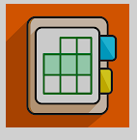

My Announcements - This could be your own announcements or institutional announcements.

Report Card – Generally the total column in the gradebook is set as the external grade. For student the external grade column displays here. This is a quick reference to let them know how they are doing in each course.

Follett Discover – Provides quick access for both students and faculty to the books they need each semester.

My Courses – Lists all the courses you have/had, courses are divided by semesters. When a course disappears from your view it’s because you have been unenrolled in it.
Overview of the Learn Dashboard

TOP TABS
My Institution - Redirects to the main Blackboard landing page.

Courses - Redirects to your courses.

Content Collection – Blackboard Content Collection is a file repository that allows faculty and students to store, manage, and share content.

System Admin - Not visible for faculty and students.

WVNET Help Desk – West Virginia Virtual Network is housed in Morgantown, WV and they provide afterhours help to faculty and students. When needed just click on the tab and create a detailed trouble ticket.

Standard Course Template
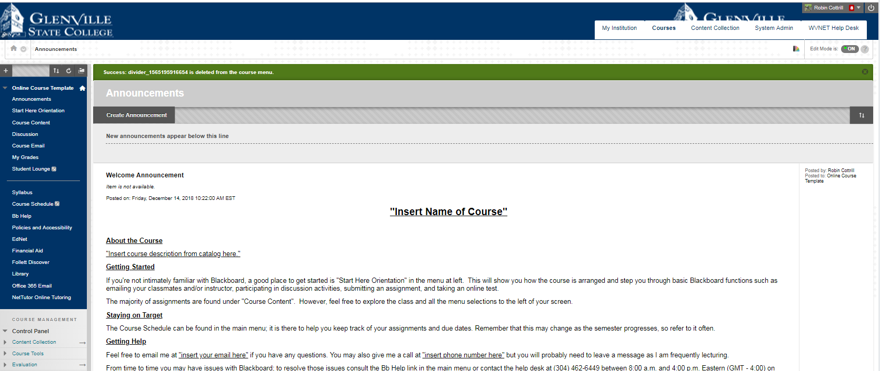
MENU ITEMS
All courses start with the standard template including menu items, color, and design. Glenville State College is a member of Quality Matters(QM) and our course template complies with QM standards. You can copy/paste prior course work into a new course. It’s recommended you have master course copies and copy your content from the master into the new course.

Announcements - A standard announcement is created for you. You will need to update it with your information and make it visible to students.

Start Here Orientation - This section is recommended for 100 and 200 level courses. If you do not feel your students would benefit from this content please hide it from student view.

Course Content - All course content should be housed here in an organized manner.

Discussion - Quick link to discussion board. Online courses should have weekly discussions.

Course Email - This email is tied to your office 365 email but housed within Blackboard.

Student Lounge - This feature comes hidden. It is a place for students to communicate with other students.

Syllabus - Every course should have a syllabus posted in Blackboard. A copy of the template is provided for you in Blackboard.

Course Schedule - It’s recommended you post a course schedule for your students separate from the syllabus, a sample is provided. (This menu item is hidden from student view.)

Bb Help - Provide contact information for both local help and the 24/7 support desk.
Standard Course Template

MENU ITEMS (continued)
Policies and Accessibility – This section links to policies and information that relate to students.

EdNet - Provides a quick link to the log in page for EdNet.

Financial Aid - Provides a quick link to the financial aid web page.

Follett Discover - Links directly to the Follett page and is relative to the courses you have. This is also on the main landing page.

Library – Provides a quick link to the library’s web page.

Office 365 Email – Provides a quick link to the log on page for Office 365.

NetTutor Online Tutoring – NetTutor is integrated with Blackboard. Should a student need tutoring they can click on this link and services are automatically available to them. No need to log onto a separate portal.

Working in Your Course
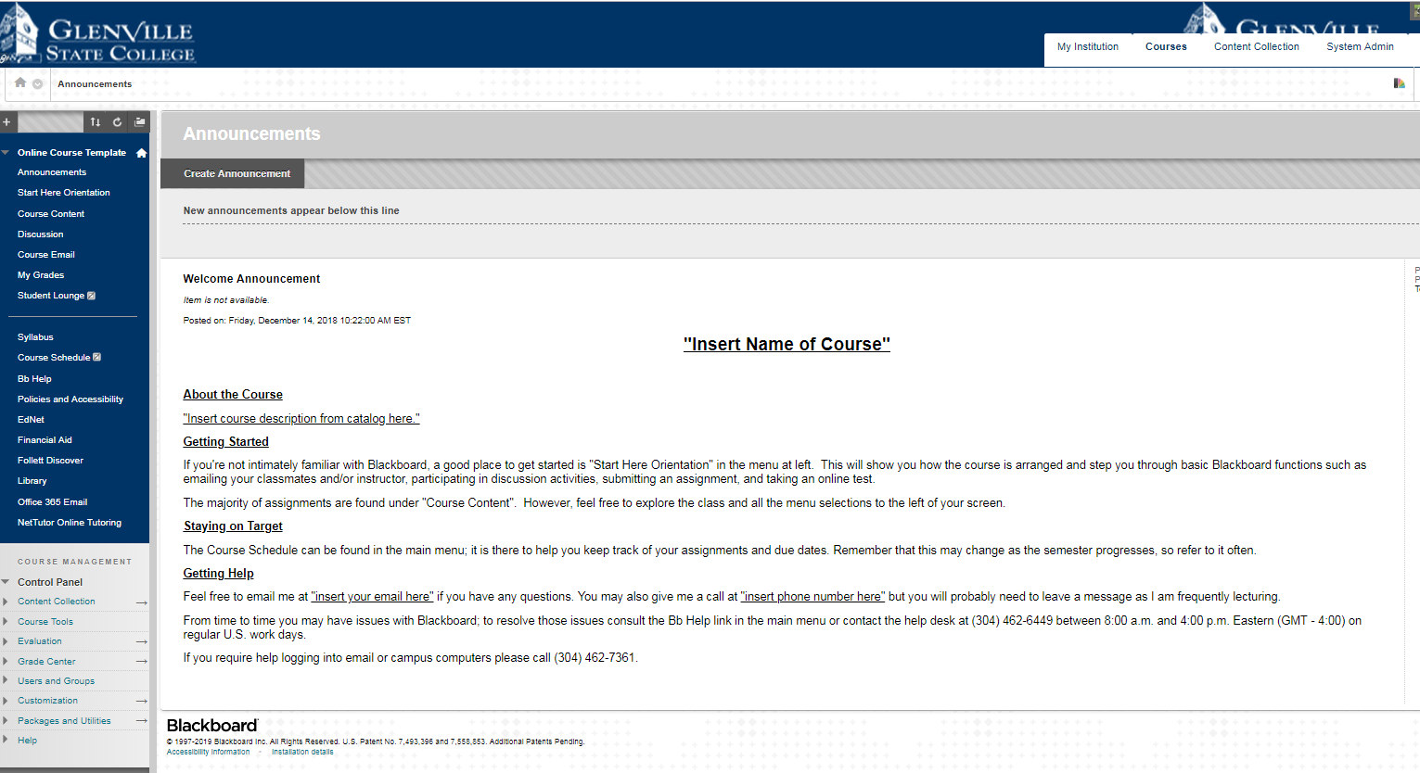

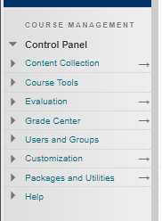

The “Course Management” section is only visible to faculty/instructors and teaching assistants, not students.
Working in Your Course

The “Course Management” area houses the “Control Panel” for your course.

Content Collection - Contains all the course files in the file repository.

Course Tools - Contains all the available tools that are added to your course.

Evaluation - Provides links to course reports, the retention center, and the performance dashboard. You can use these tools to view information about student activity and content usage.

Grade Center - Provides links to the “Needs Grading” page, the “Full Grade Center”.

Users and Group - Lists all users/groups in your course.

Customization - You can change the properties of your course such as its name, availability and language pack. You can use the Quick Setup Guide and Teaching Style page to modify the appearance of your course. You can also change tool availability to control which tools are available in your course and which users have access to them.

Packages and Utilities - Import, export, and archive a course, check course links, copy all or part of the course, and move selected files to Content Collection

Help – Offers online documentation.

Working in Your Course

Available Views
When working in your course make sure the “Edit Mode” is “On”.

If edit mode is not on, you will not be able to make changes to your course.

Student Preview

The Student Preview mode allows you to view the course the way a student would see it. This is very helpful when designing your course, especially if you question if an item is visible to students.

Creating Announcements
If your course is online you should have weekly announcements.

Step 1: To create an Announcement, make sure your Edit Mode is on.
Step 2: Click Announcements, then Click Create Announcement.

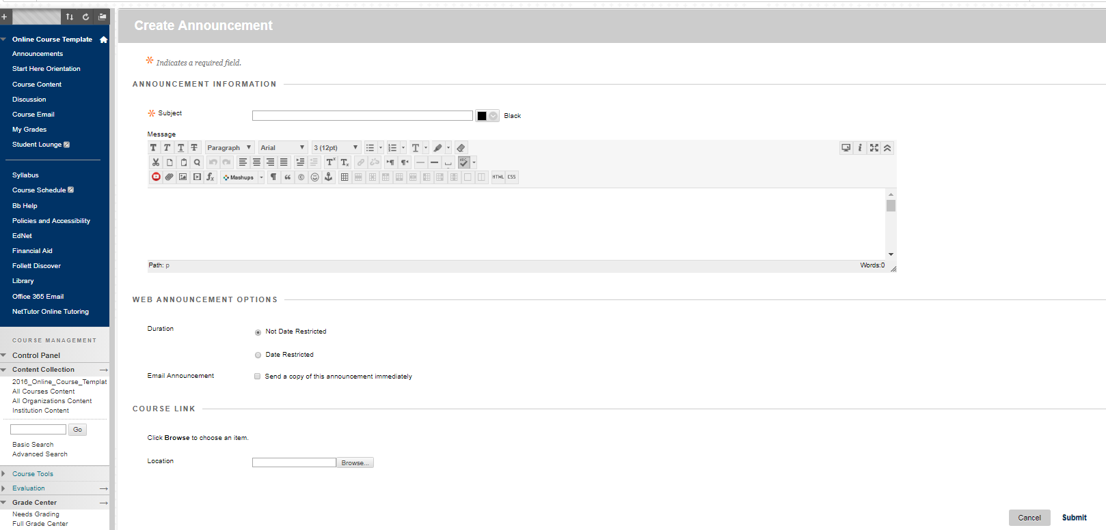
Creating an Announcement
Step 1: Give your announcement a subject.
Step 2: Type your message.
Step 3: Decide if you want to give it a date restriction.
Step 4: It’s recommended to send an email copy of the announcement.
Step 5: Click submit.
Start Here Orientation
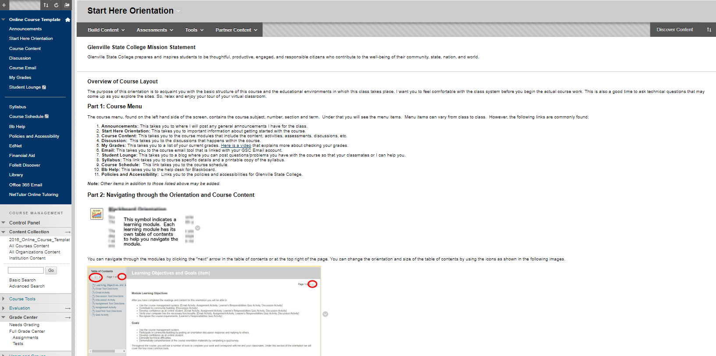
The Start Here Orientation menu item is an orientation to Blackboard for your students. It is your discretion to use or not use the orientation. It is recommended for 100 and 200 level courses. The orientation comes complete with four assignments that acclimate students with emailing, posting discussions, uploading assignments and the final activity is a quiz. The quiz verifies the student read such things as the syllabus, disability policy, academic dishonesty policy, etc. It is also your discretion to give these assignments points.
Course Content
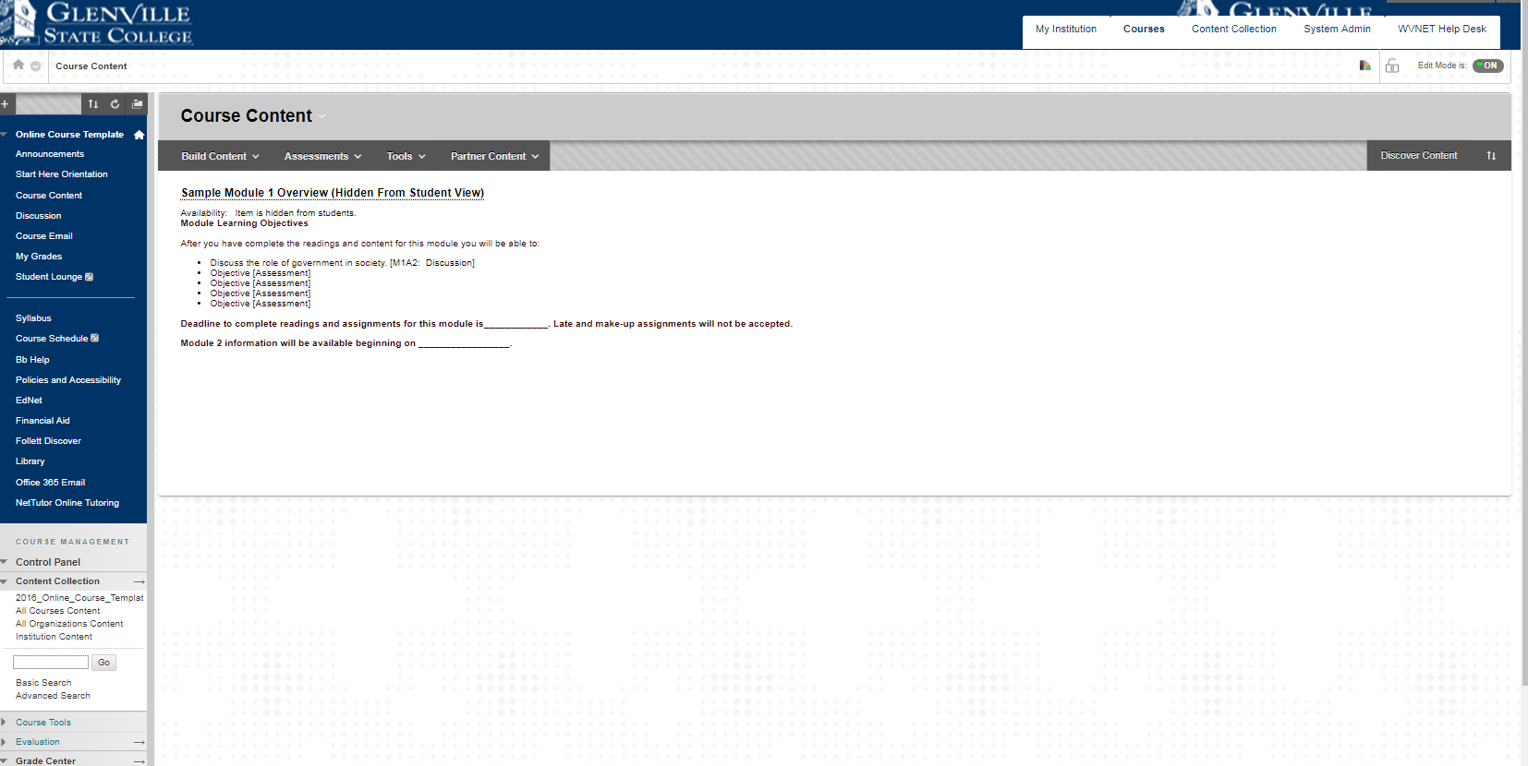
When adding course content, it’s recommended to label course work by modules as the example shows.
Adding Course Content
With Edit Mode on, under Course Content, hold your mouse over Build Content. From the drop down menu select Content Folder or Learning Module. Learning Modules are set up with an outline view of the content. A Content Folder is just like a folder on your desktop.

Name your new folder and select a text color. In the textbox you can enter a description or directions along with a picture, sound, etc.
Adding Course Content
Make sure you have selected Yes to Permit User to View this Content if you want students to see this file. Also, select Yes if you want to Track Number of Views. You can also set Date and Time Restrictions on the availability of the item. When you are finished, click Submit.

Notes: _____________________________________________________________________________________________________________________________________________________________________________________________________________________________________________________________________________________________

Example of a Course Layout
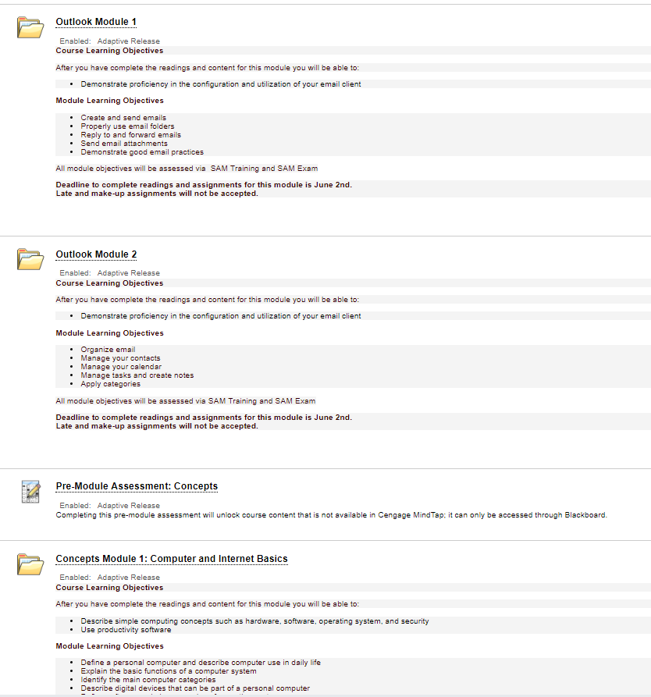

Notice how course learning objectives, module learning objectives, and due dates are all easliy identifiable. You can turn the availbility of a file folder on or off. Within each folder there are several assignments from a variety of sources.

Adding a File
Hold your mouse over the Build Content then select File.

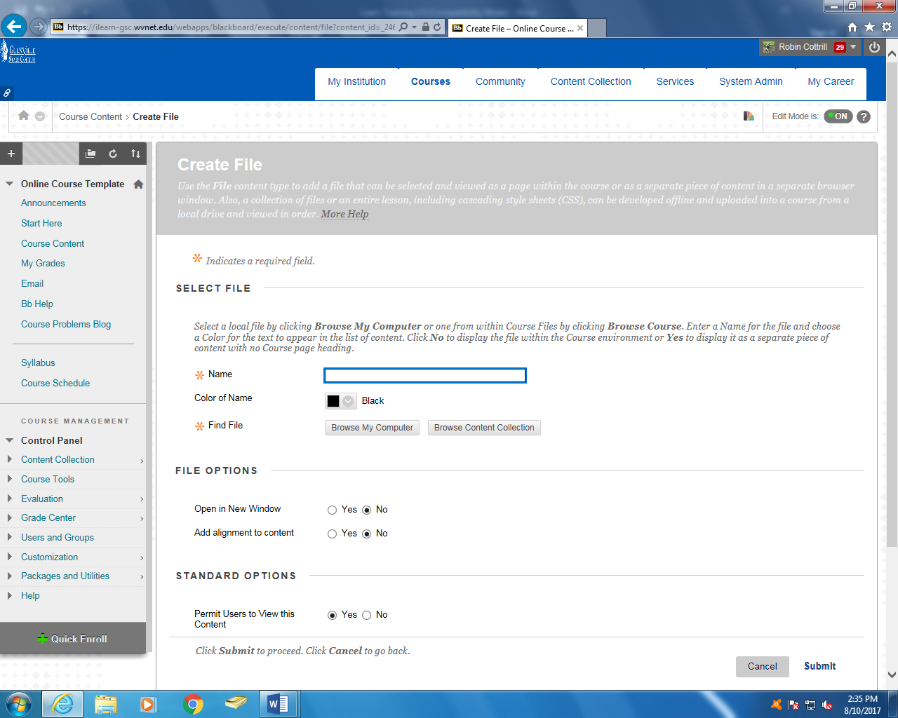
Name your file. Click Browse My Computer to select the file you wish to upload. You can set time and date restrictions and change the font color. You can select Yes to Track Number of Views. When finished, click Submit.
Adding an Image
Hold your mouse over Build Content,
from the drop down menu select Image.

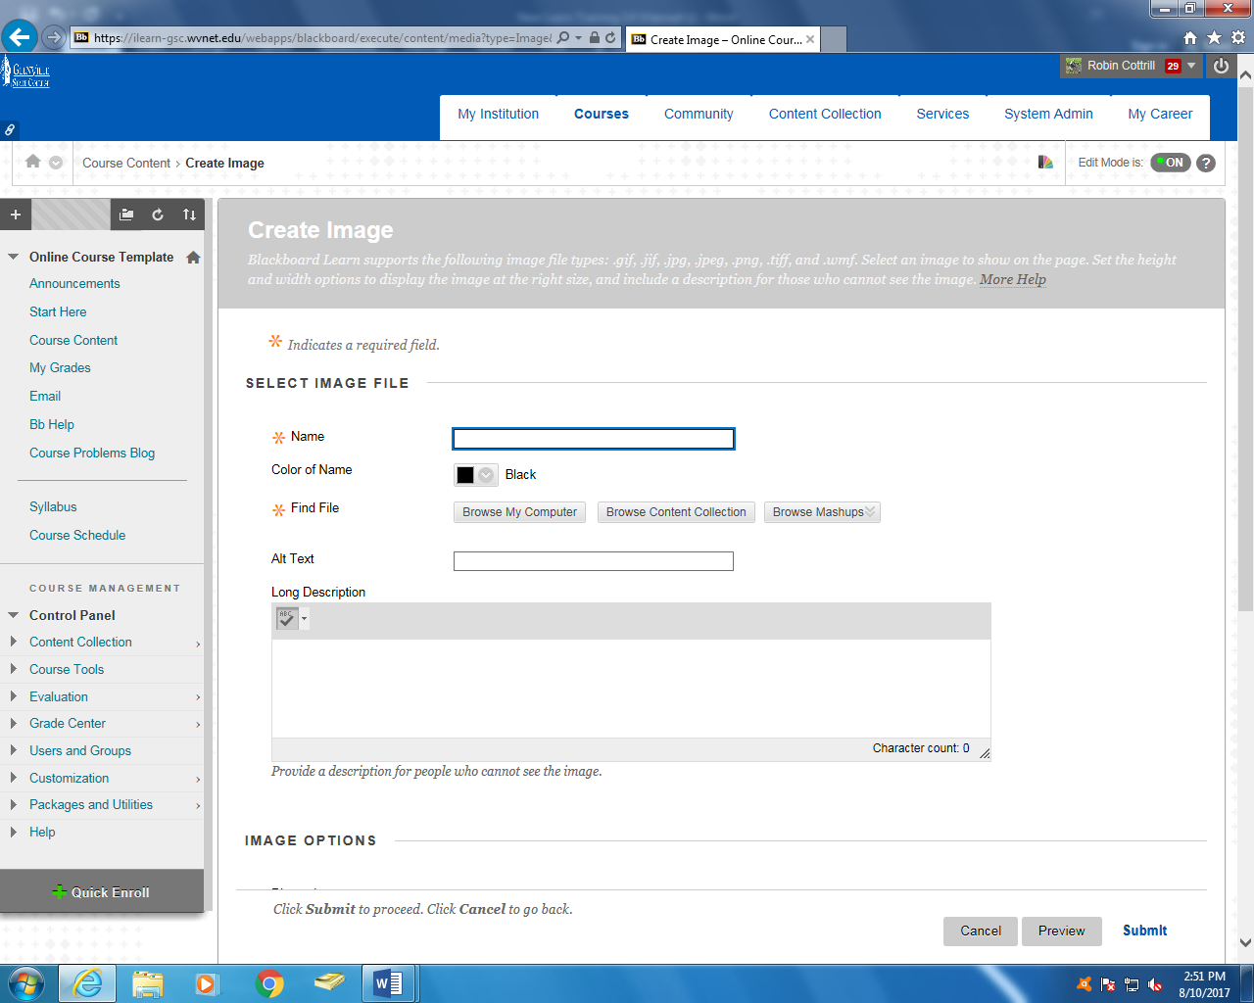
Name your file. Select Browse My Computer to find the image you wish to upload. [Note: Supported Images types are .png, .jpg and .gif.] You can also change the font color or add a description.
Adding an Image
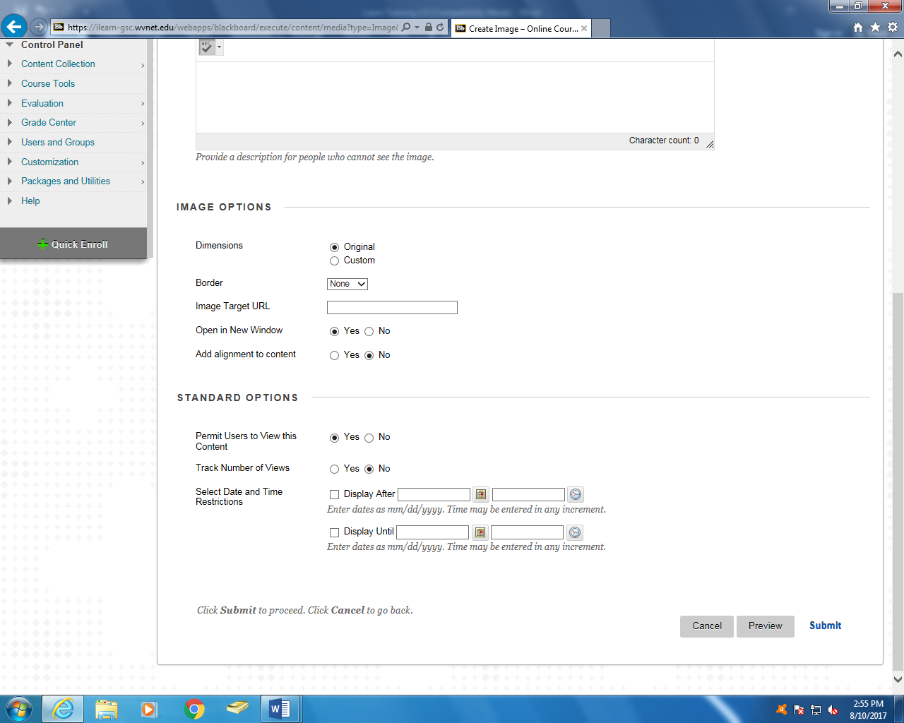
You may add a border to your image. Further down the page you will see Track Number of Views; select Yes if you wish to track the item. You can set Date and Time Restrictions. Click Submit when you are finished.

Adding a URL (Web link)
Hold your mouse over the Build Content action link and select Web Link.
Adding a URL (Web link)
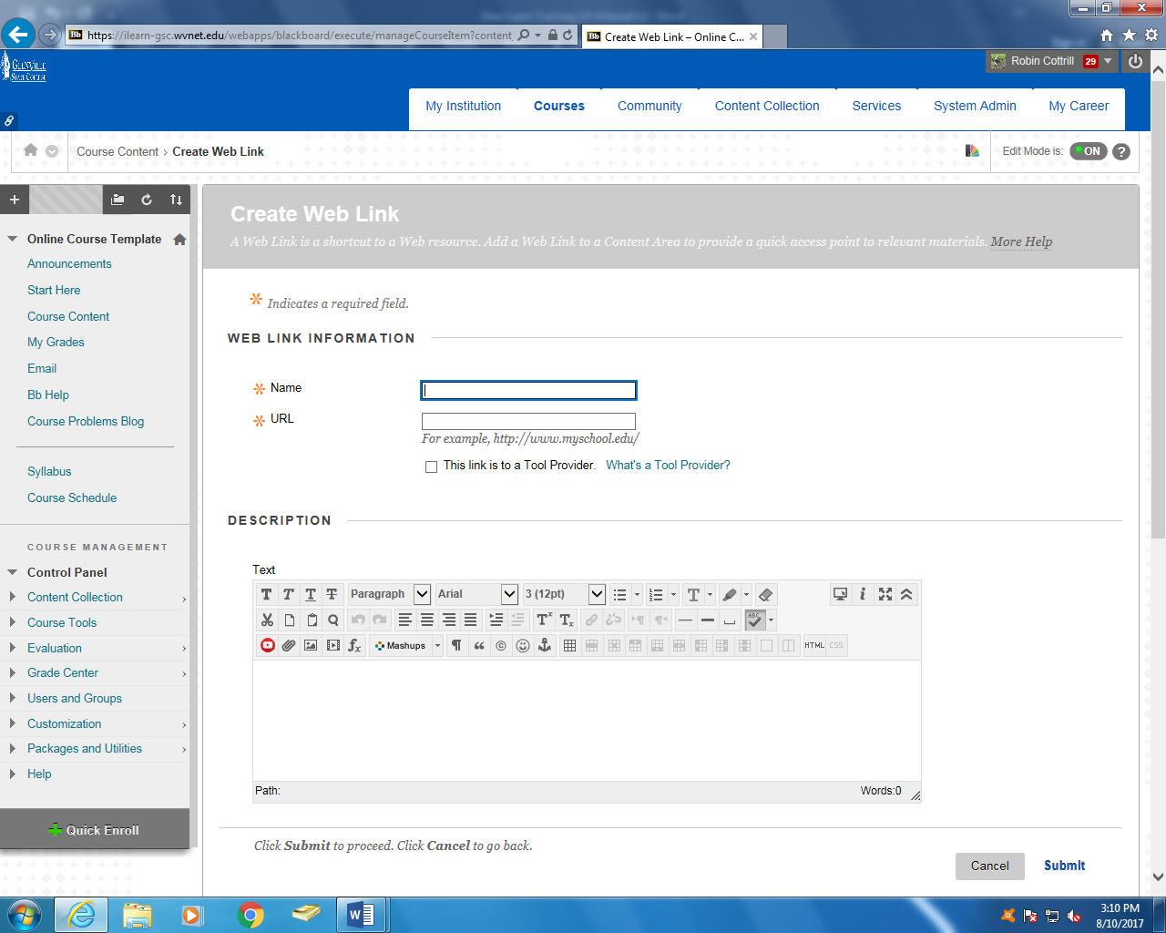
Name your URL, add the web link (make sure the web link includes the http://) and then give it a description.
Notes: _____________________________________________________________________________________________________________________________________________________________________________________________________________________________________________________________________________________________
Adding a URL (Web link)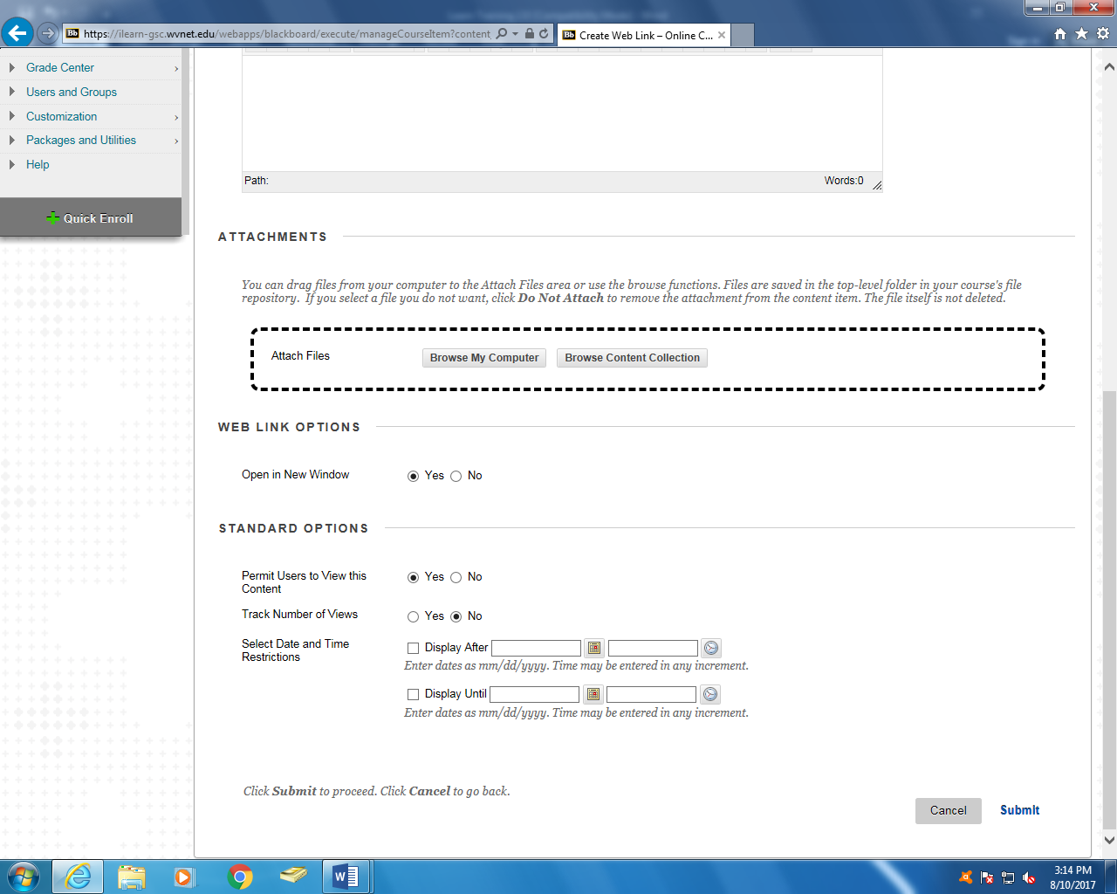
You can add Date and Time Restrictions and choose tracking, viewing, and opening options. Once you are finished, click Submit.

Notes: _______________________________________________________________________________________________________________________________________________________________________________________________________________________________________________________________________________________________________________________________________________________________________________________________________________
Creating a Test
Hold your mouse over Assessments, from the drop down menu select Test.

To create your test, select Create. If you have created your test in the Test, Survey, and Pools area you will see it in the box and be able to select Add an Existing Test. If you are using a test from the publisher you can upload it under the Test, Survey, and Pools area under course management.
Creating a Test 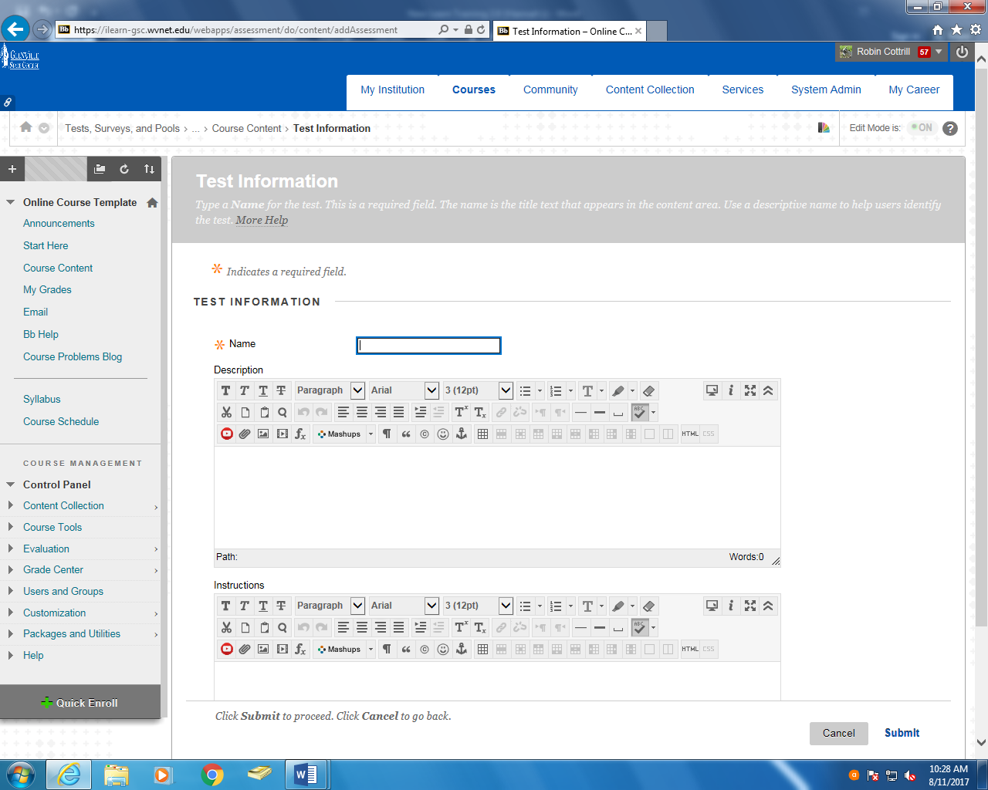
Name your test, give it a description, and provide instructions. Click Submit.

Notes:
_____________________________________________________________________________________________________________________________________________________________________________________________________________________________________________________________________________________________

Creating a Test
Hold your mouse over the Create Question action link; from the drop down menu select a type of question. Types include: Multiple Choice, Short Answer, True/False, etc. Each question has a slightly different creation process. We will demonstrate how to create a Multiple Choice question. To begin, select Multiple Choice from the menu.

Notes:
_____________________________________________________________________________________________________________________________________________________________________________________________________________________________________________________________________________________________

Creating a Test
Title your question and add your text in the appropriate field.

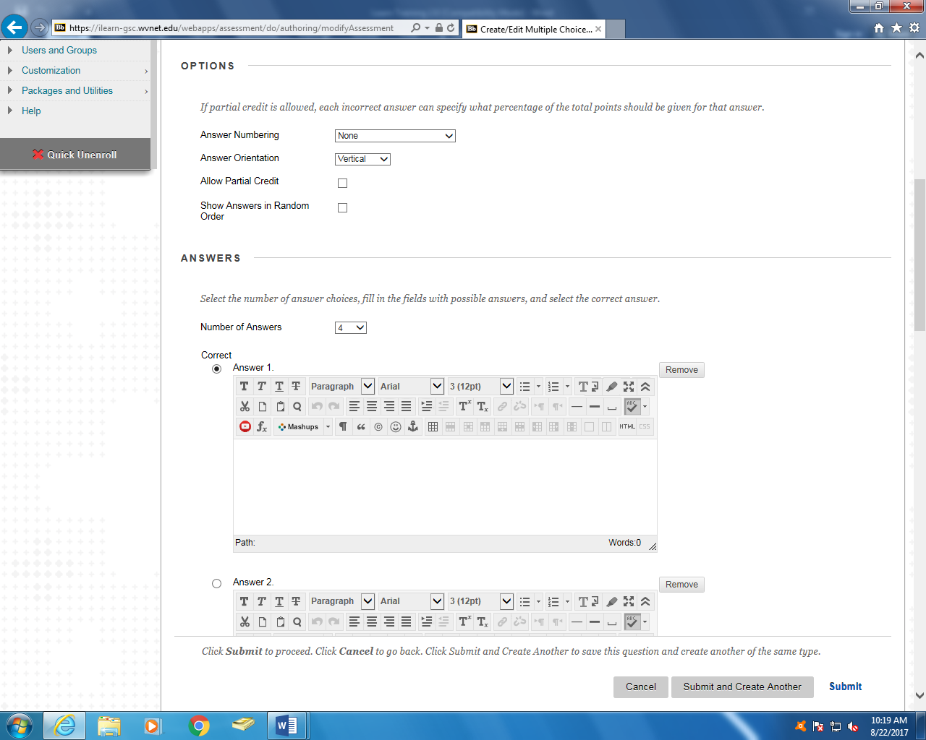
Next select the Number of Answers you would like to have and type the answers in the boxes provided. Be sure to indicate which answer is correct. Once you are finished, click Submit.
Select your Answer Numbering from the drop down menu. Then select your Answer Orientation and whether or not you would like your answers to be random.
answers to be random.
Creating a Test
When you click on the drop-down arrow beside a test or quiz you have the ability to: 1. edit the actual test 2. edit the test options 3. set adaptive releases 4. move the test or 5. delete the test
Edit the Test Options
You can give your test a name and description. You can set it to open in a new window. Test Availability settings are very important. If No is selected for Make the link available students will not be able to see the test. You can also create an announcement for the test.
Edit the Test Options
You can allow multiple attempts, force students to complete test, set a timer, have an exact start and end time and even make the test password protected. Also note that most premade tests are available online and students will cheat. It is safest to always develop your own tests.

It’s preselected for the test grade to post in the grade center. You can allow feedback to student. You can also select different test presentations, some of which prohibit cheating. When finished click Submit.
It’s best to have questions appear one at a time and prohibit backtracking.
Creating a Test
From the drop down button of the Quiz Activity item you also have the ability to Move the test to another section within the course or Delete the test.
Setting Adaptive Release
You can set adaptive releases for tests and other items. When you open the drop-down menu beside an item you will see Adaptive Release.
Setting Adaptive Release
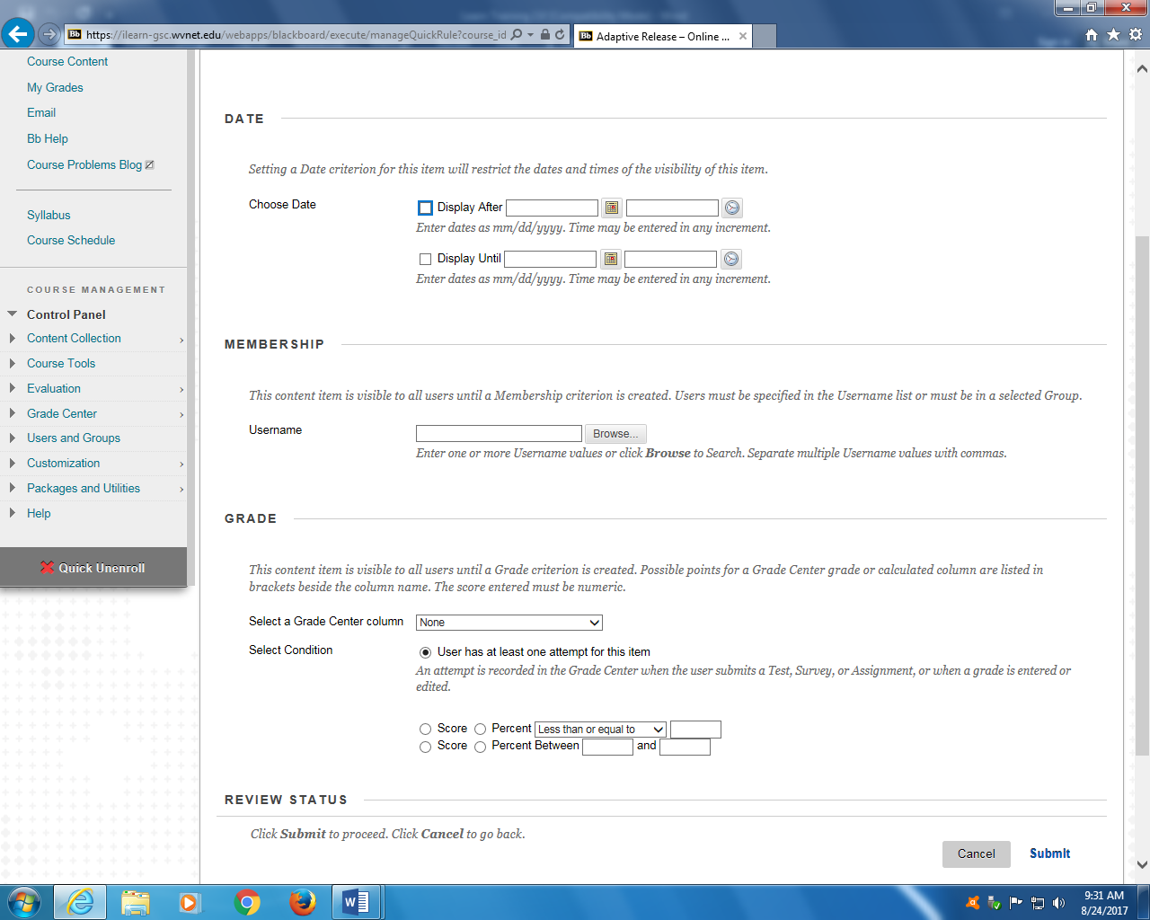
Select the dates that you would like the item to be available. You may also choose to release to individual students or groups of students. Don’t forget to add the item to the grade center and set grading options. Click Submit when finished.

Notes:_____________________________________________________________________________________________________________________________________________________________________________________________________________________________________________________________________________________
Sending Email
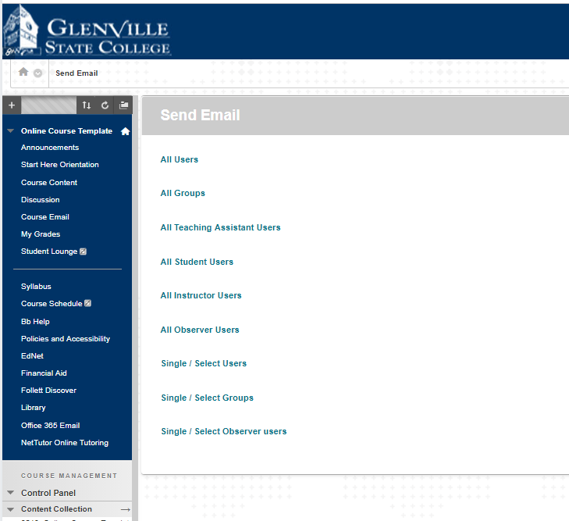
Within your course on the side menu click Course Email. Then from the screen prompted, select the option that best fits your needs. Please note that your email may go into the students junk or clutter box.
Notes:____________________________________________________________________________________________________________________________________________________________________________________________________________________________
Sending Email
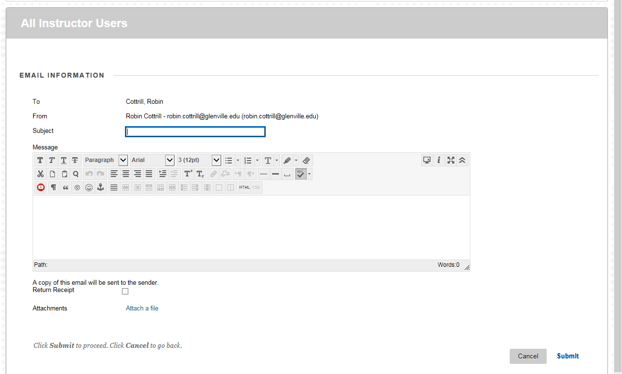
Once you have sent your email, a copy of the message will be sent to your Glenville email and the actual message will be sent to the student’s Glenville email account. [Note: Messages are external and will NOT be saved in the Learn system!]
Browse to select your recipient, and then provide a subject and message for the email. Attach a file if you wish, click Submit when finished.
Bb Help
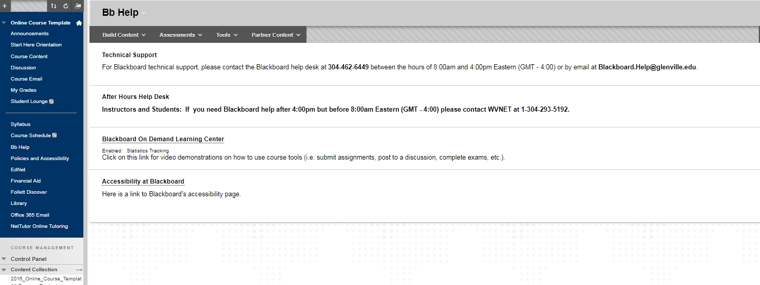
Bb Help is built into every course, it has contact information for local and after hours help. It also has educational videos for faculty and students.

Student Lounge
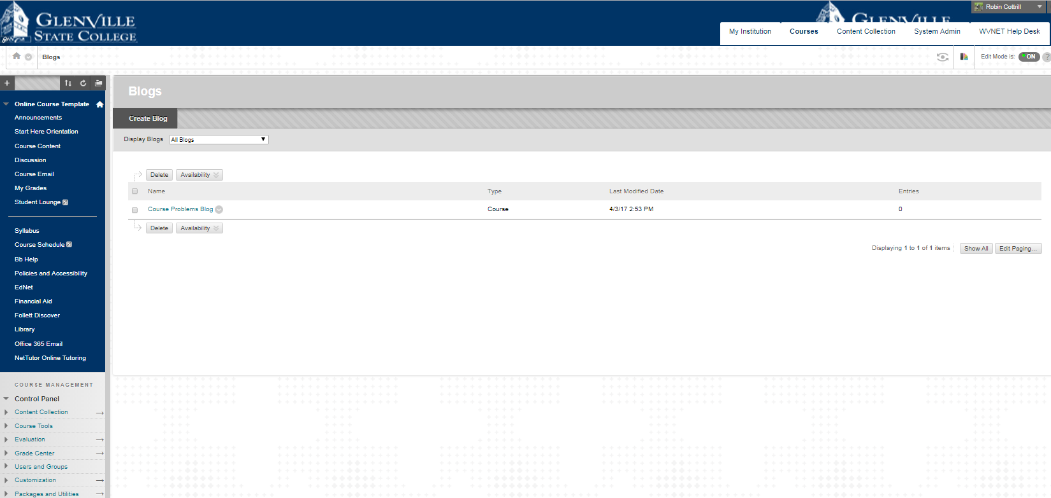
This feature comes hidden. If you want to use it, you will have to make the link visible to students. The lounge or blog is a place where students can post about the class and either faculty or other students can answer those posts.

Syllabus
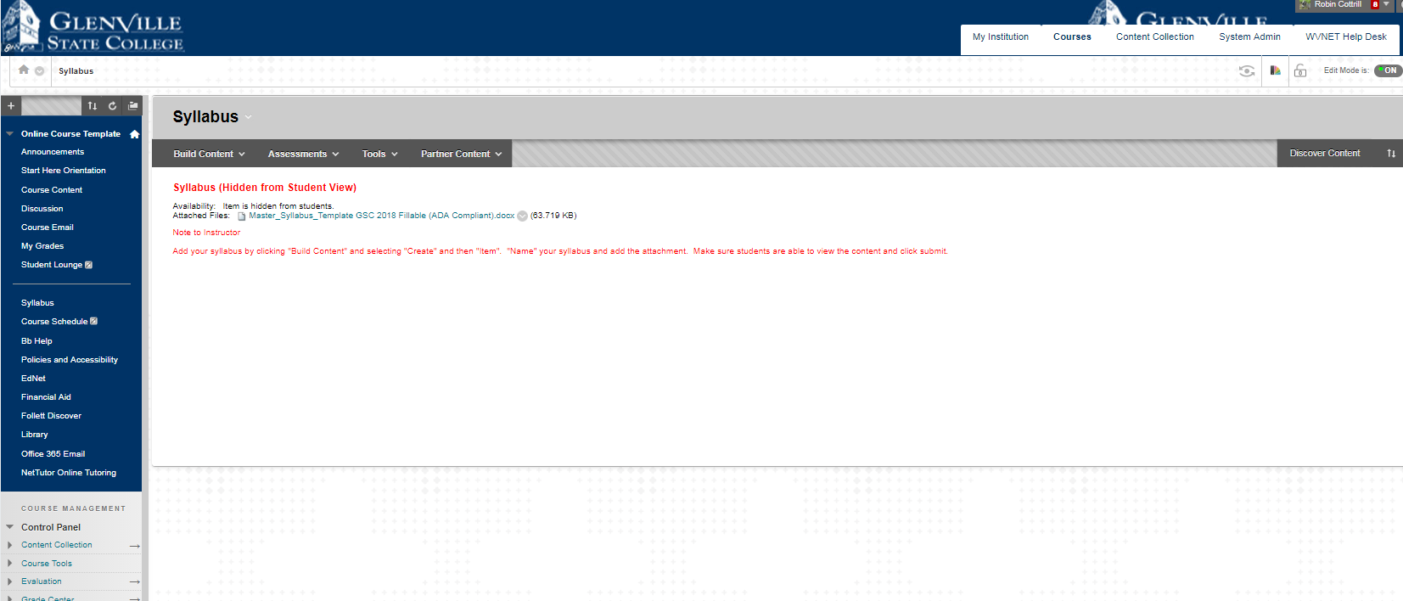
The Syllabus section is where you post your syllabus. You can either add it as an item or a file. It is recommended to post your syllabus in Word format. PDF formats are harder to manipulate for those students with disabilities that need to increase the font size.

Creating an Assignment
Under Course Content, click on Assessments, then select Assignment.

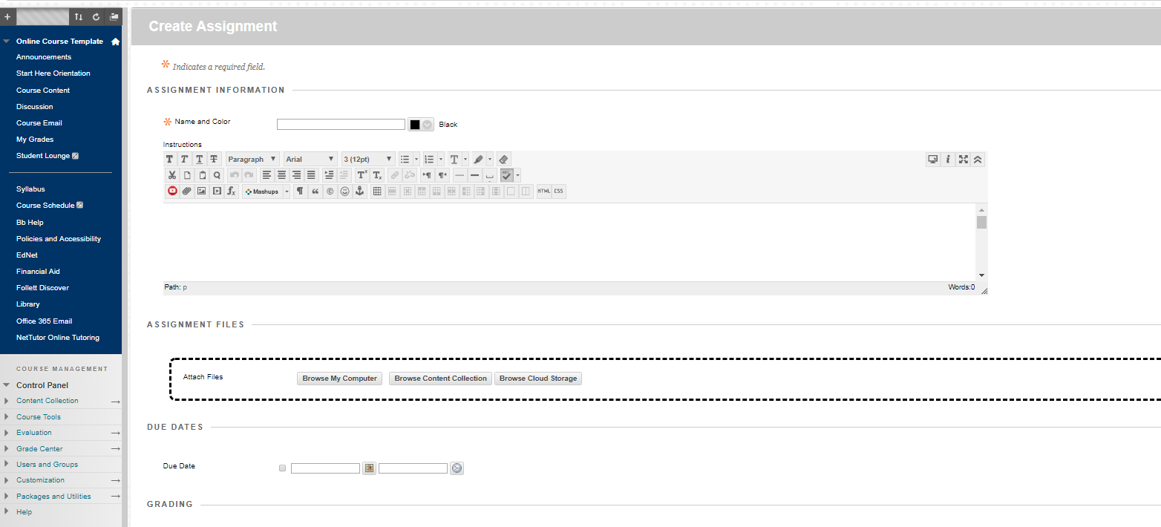
Name your assignment and type instructions. You can attach a file if you would like. You can also assign a due date.

Creating an Assignment
You must enter the number of points possible. [Note: Setting Points Possible automatically creates a column in the Grade Center]
You can choose to add a rubric. If you click on Submission Details you have more choices. If you decide to use the plagiarism tools, the student’s work will be checked for violations and you will receive a report.

When you click on Grading Options and Display of Grades more options become visible. You can set the availability of the assignment and track the number of views and click Submit when finished.

Creating a Discussion Board
A discussion board is a great tool that can create communication within your course. To create a discussion, select Course Content from the course menu. Then select the Tools tab, then click Discussion Board.
*If you are teaching a course that is 100% online is it imperative that you have several discussion activities thoughtout the semester to show good communication between faculty and students.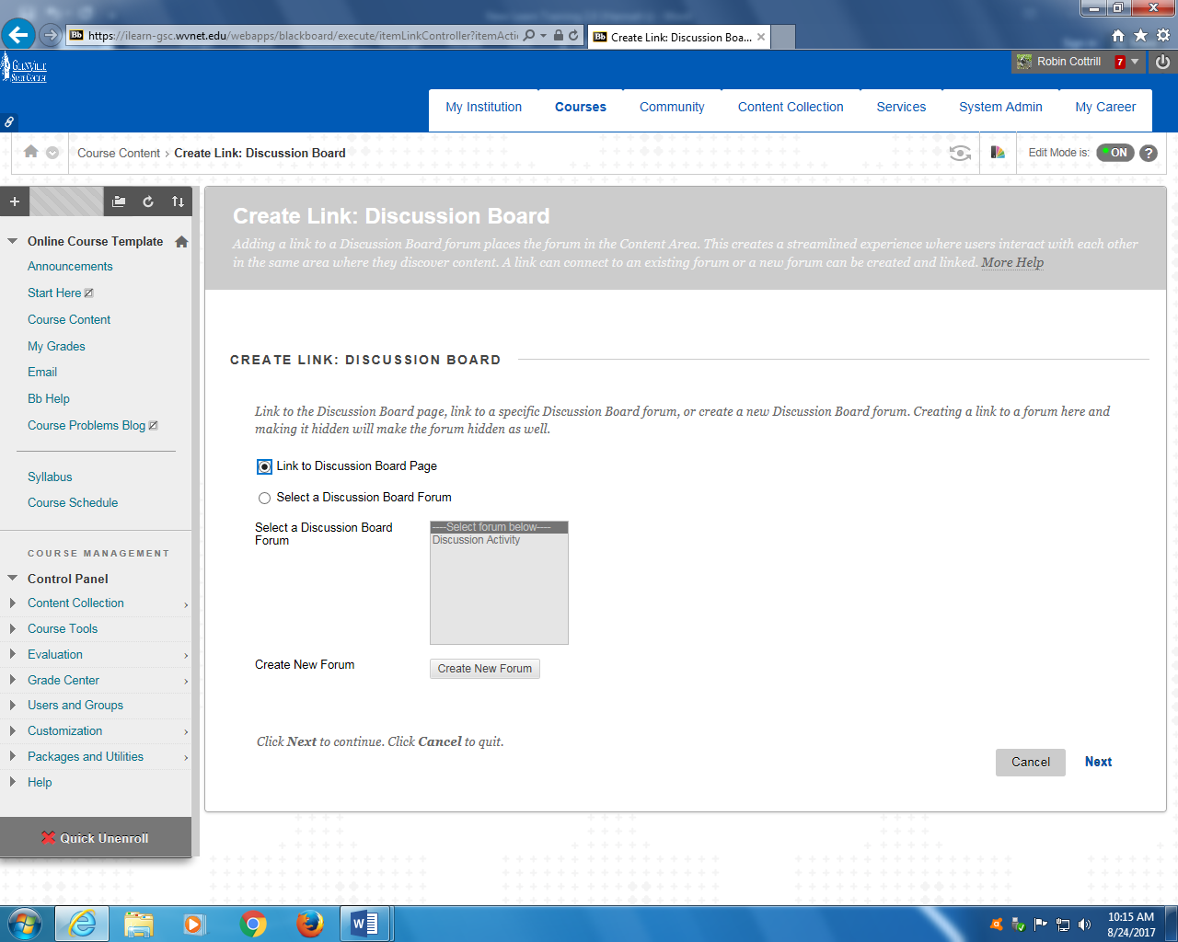
Click Create New Forum, then click Next.
Creating a Discussion Board
Title your forum and add a description.
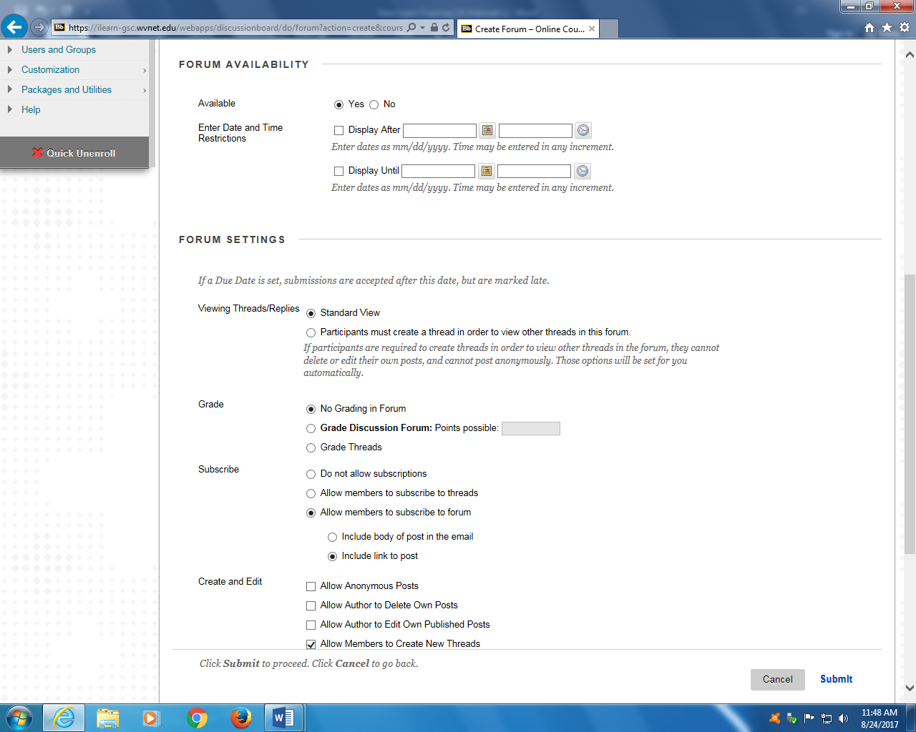
Set the availability and choose the settings that you would like, and then click Submit.
Creating a Discussion Board
Once you have created your forum, you can start a thread. Click on the name of your forum.

Click Create Thread.

Creating a Discussion Board
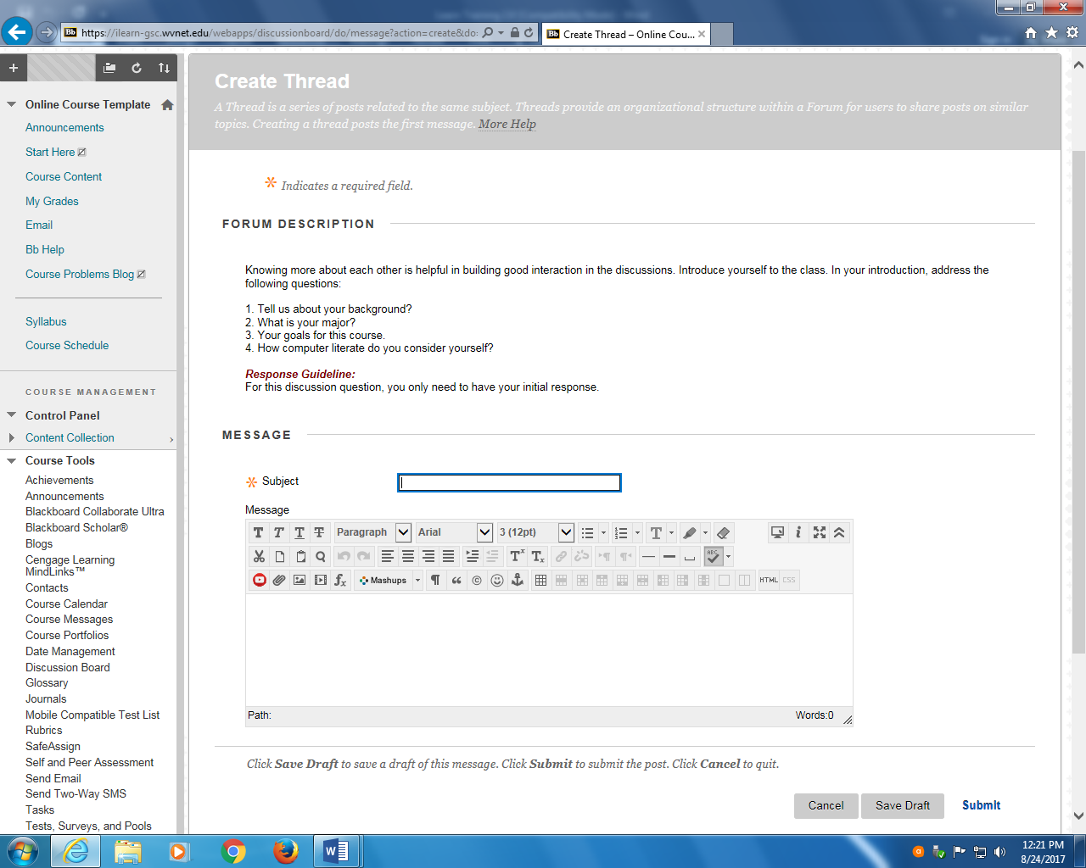
Type in the Subject of your thread and add a message. You can also add an attachment. When you are finished, click Submit.
To reply to a message in the forum, click on Thread.
Creating a Discussion Board
Click Reply.

Type your message, and/or attach a file and click Submit.

Navigating the Grade Center
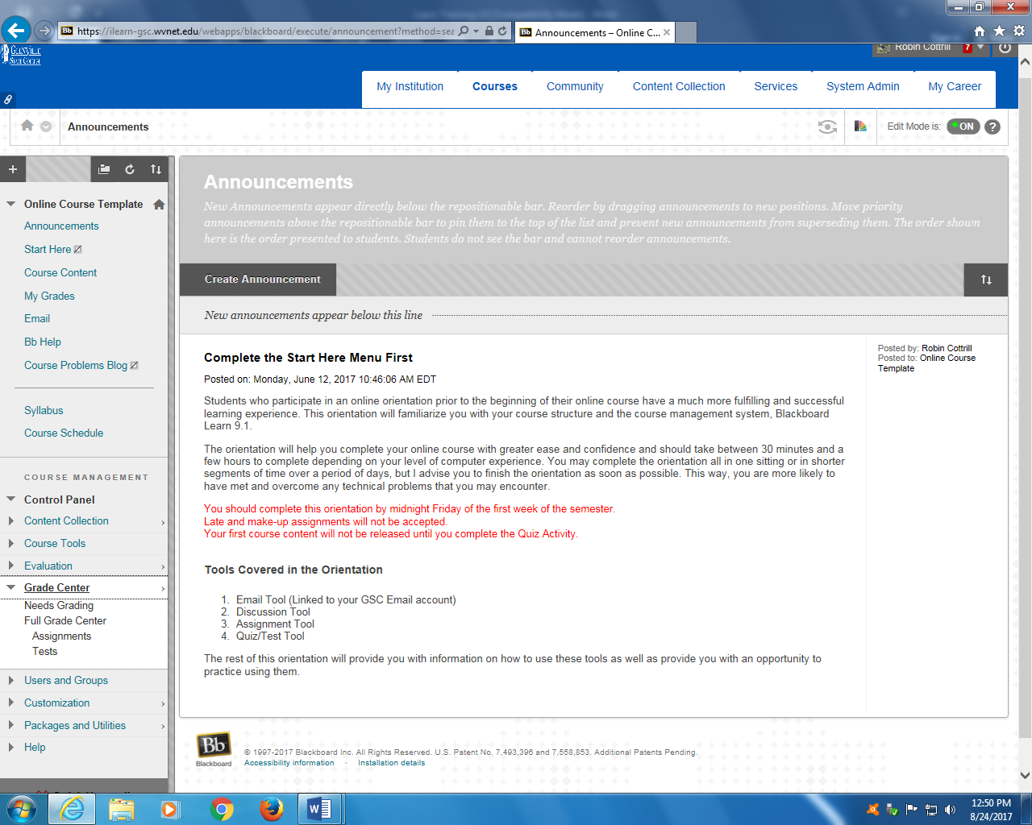
The Grade Center is broken down into four areas: Needs Grading, Full Grade Center, Assignments, and Tests.
Needs Grading shows only items that need graded.
Full Grade Center shows all users and all items in the course.
Assignments shows only assignments for all users.
Tests shows only tests for all users.
Notes: ____________________________________________________________________________________________________________________________________________________________________________________________________________________________________

Full Grade Center
The Full Grade Center displays the student’s ID number, last access date, and grades.

When you click on the down arrow by the column you have several options, including deleting the column.
Full Grade Center
To change the display of the Grade Center click on Manage and then Column Organization.

You can move columns by clicking on the cross arrows and then dragging it where you want it. Click Submit when finished.
You can hide columns by selecting the box and then clicking on Show/Hide. Click Submit when finished.

Full Grade Center
You can create a column by clicking Create Column.

You must give your column a name and list the number of points possible.

Full Grade Center
Make sure you select the correct value.

You can add a rubric and set due dates. The options are mostly likely set how you would like, but you do have the ability to change them. When finished click Submit.

When students fail to complete an assignment do not leave the grade area blank. Doing so causes that assignment to not total in the student view. You must enter a zero.

Copying Course Content
In order to copy content from one section to another in Blackboard the Course ID for each Destination Section must be identified.

The Course ID is located under the Courses tab.

The Course ID format is CRN.Term Code for example 2780.201801. If the course is a Master Course Copy then the Course ID will have the word master in the title for example Master-CSCI-201-Intro_to_Computer_Programming-Ward.

Examples below.
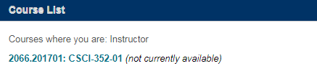

Next, identify the Course ID for the new course. _________
Then, idenify the Course ID for the old course, the one you are copying. ________
Next, enter the old or original course.

Copying Course Content

Once in the course, go to the course management section on the left and select Packages and Utilities.
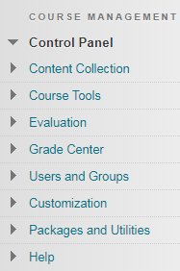

Then click on Course Copy.
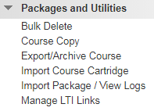

Copying Course Content

Select Copy Type:
From the drop-down menu, select Copy Course Materials into an Existing Course.
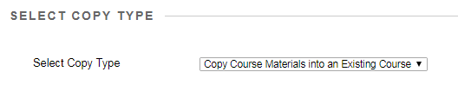
Select Copy Options:
Enter the Destination Course ID of the new course. You may have the option to browse here. Instead of clicking “Browse”, manually enter the Destination Course ID using your keyboard.
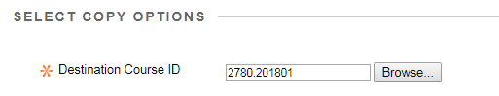
Select Course Materials:
Click Select All
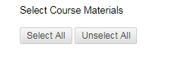
When you click “submit all” all items will become selected. If you don’t want to transfer a section simply uncheck that box. Careful of importing duplicate items.

Copying Course Content

File Attachments:
Course Files, select “Copy links and copies of the content (include entire course home folder)
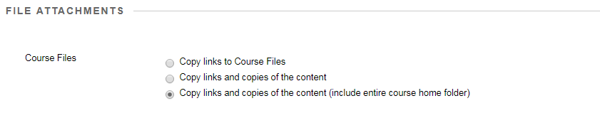
Enrollments:
DO NOT check the “Include Enrollments in the Copy”
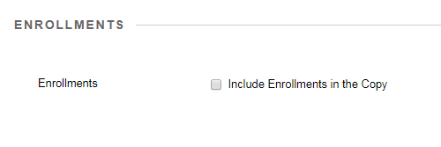
Click Submit at the bottom of the page.
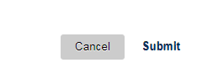

If you did accidentally import duplicate items just delete what you don’t need. Make sure you check the gradebook for duplicates.
Notes: _______________________________________________________________________________________________________________________________________________________________________________________________________________________________________________________________________________________________________________________________________________________________________________________________________________

Questions or for More Information

For Blackboard technical support, please contact the Blackboard help desk at 304-462-6449 between the hours of 8:00am and 4:00pm or by email at Blackboard.Help@glenville.edu.

You may also visit the “Discovery” area within your Blackboard.

If you need Blackboard help after 4:00pm but before 8:00am please contact WVNET at 1-304-293-5192

